ASSIGNMENT 14

Name : Akanksha Joshi

Roll No : B038

Batch : 3

Div : BTech CS B

Implement the following in Python:

A. Display all even numbers between 50 and 80 (both inclusive) using "for" loop.

Source Code

print(**"All even numbers between 50 and 80(both inclusive) are : "**)  
**for** i **in** range(50,81):  
 **if** i%2==0:  
 print(i)

Output

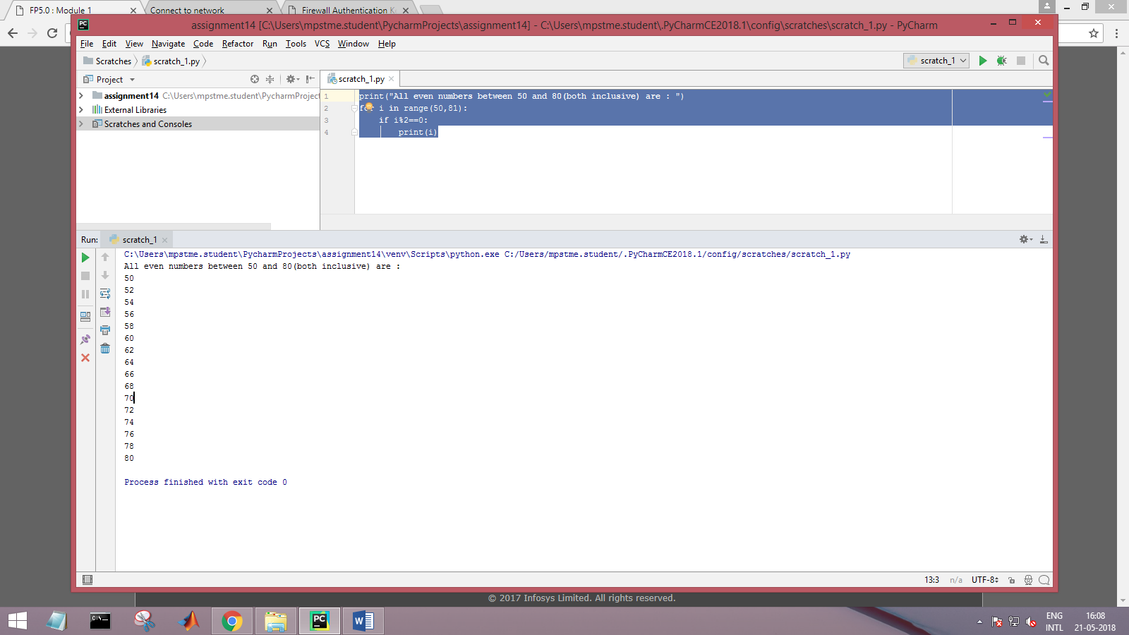

B. Add natural numbers up to n where n is taken as an input from user. Print the sum.

Source Code

num = int(input(**"Enter the number : "**))  
sum=0  
**for** i **in** range(1,num+1):  
 sum = sum + i  
print(**"sum of all natural numbers upto the given input is : "**, sum)

Output

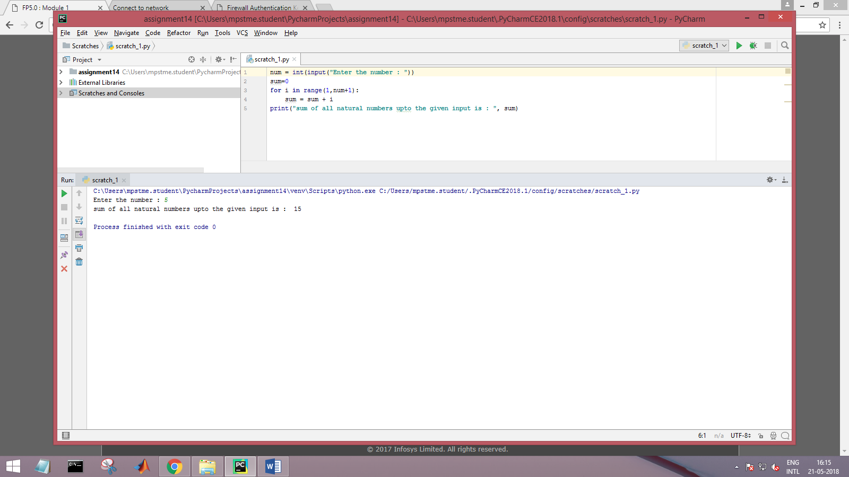

C. Prompt the user to enter a number. Print whether the number is prime or not.

Source Code

num = int(input(**"Enter a number : "**))  
count = 0  
**for** i **in** range(1,num+1):  
 **if** num%i==0:  
 count = count+1  
**if** count==2:  
 print(**"Given number is a prime number "**)  
**else**:  
 print(**"Given number is not a prime number "**)

Output

1. When number is prime

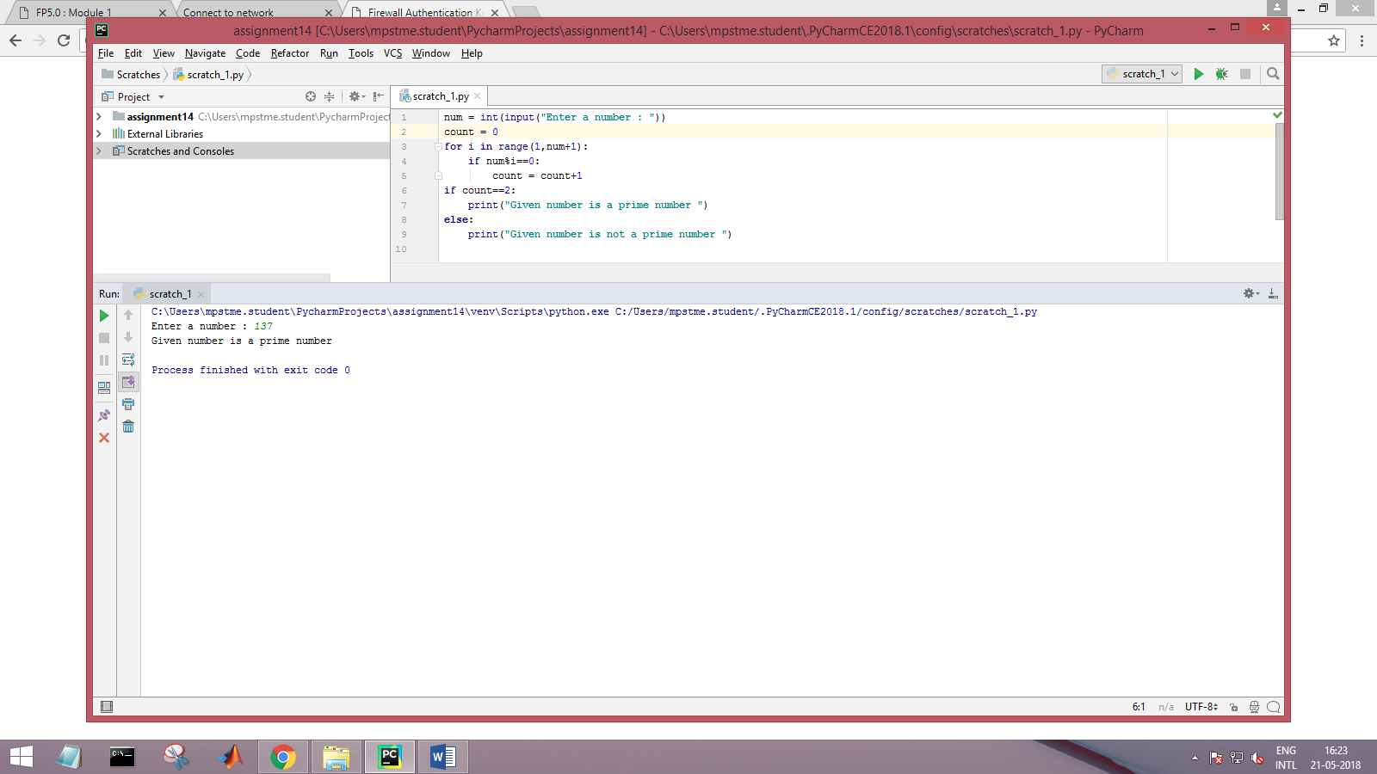

1. When number is not prime

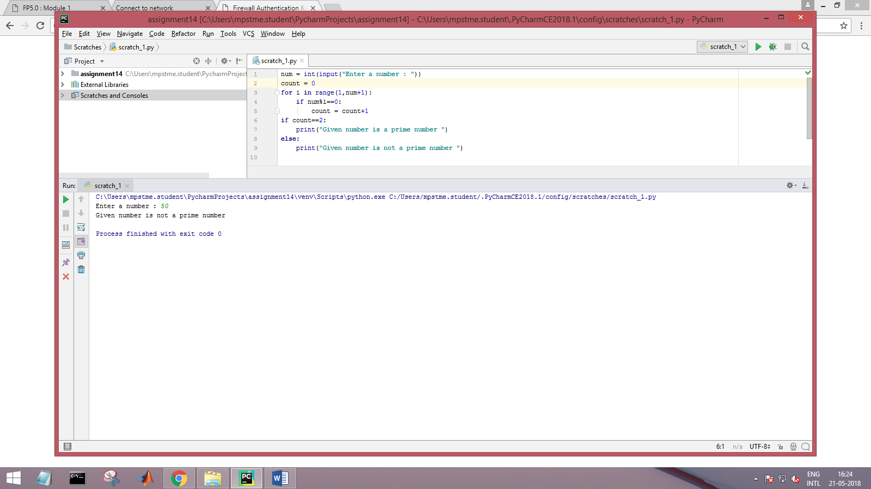

D. Print Fibonacci series till nth term where n is taken as an input from user.

Hint – Fibonacci series is a series of numbers in which each number is the sum of the two preceding

numbers.

Series start from 1 and goes like : 1, 1, 2, 3, 5, 8, 13 ….

Google it for further information.

Source Code

num = int(input(**"Enter the nth term for a fibonacci series : "**))  
n1 = 1  
n2 = 1  
count = 0  
print(**"Fibonacci sequence upto"**,num,**":"**)  
**while** count < num:  
 print(n1)  
 nth = n1 + n2  
 n1 = n2  
 n2 = nth  
 count += 1

Output

